# System Administrator Use Case Diagram

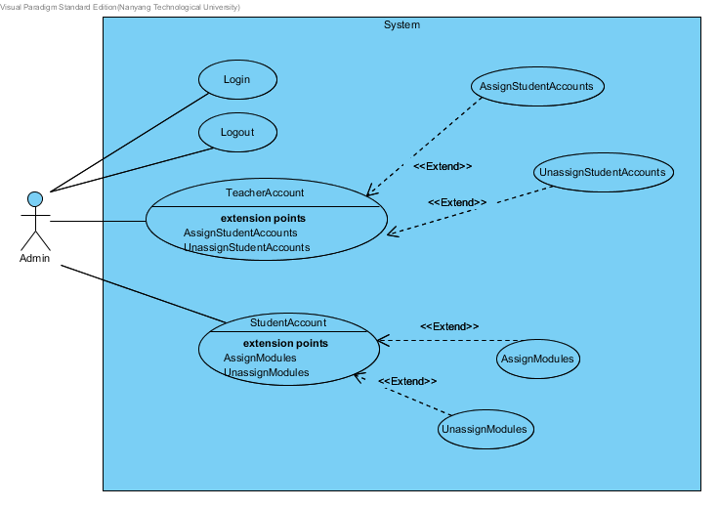

# System Administrator Use Case Description

**Login Use Case**

**Participating actors:** Admin

**Entry Conditions:**

* Admin has an authorized admin account.

**Exit Conditions:**

* Admin accesses the system and enters the Main Menu.

**Flow of events:**

1. System prompts the Admin for his/her username and password.
2. Admin inputs his/her user name and password to access to the system
3. The system verifies the credentials from the LoginServer.
4. If the credentials are verified, the system will display the Main Menu, consisting of TeacherAccounts, StudentAccounts and Logout options.

**Alternative Flows:**

AF-S3: If the Username or Password is incorrect

1. System displays the message “Invalid Login ID / Password. Please try again.”
2. System repeat step 1.

**Exceptions:**

EX1: If Admin enters the wrong Username or Password for 3 times.

1. System displays the message “The account has been locked. Please contact your system administrator.”
2. System repeats step 1.

EX2: If network is down/unavailable

1. System displays “System network down! Please try again later or contact your system administrator”.
2. System repeats step 1.

**Logout Use Case**

**Participating actors:** Admin

**Entry Conditions:**

* Admin has an authorized admin account.
* Admin is in the Main Menu.

**Exit Conditions:**

* Admin logs out of the System.

**Flow of events:**

1. Admin selects the LogOut button from the Main Menu.
2. System displays “Would you like to log off?” and prompts the Admin to select Yes or No.
3. If Admin selects Yes, System returns to the Login Menu.

**Alternative Flows:**

AF-S2: If No is selected:

1. If Admin selects No, System returns to the Main Menu.

**Exceptions:**

EX1: If the network is down/unavailable.

1. System displays “System network down! Please try again later or contact your system administrator.
2. System repeats step 1.

**TeacherAccount Use Case**

**Participating actors:** Admin

**Entry Conditions:**

* Admin has an authorized administrative account
* Admin is in the Main Menu.

**Exit Conditions:**

* Admin selected either AssignStudentAccounts or UnassignStudentAccounts

**Flow of events:**

1. Admin selects TeacherAccount in the Main Menu.
2. System displays and prompts the Admin to select from a list of TeacherAccount.
3. Admin selects the desired TeacherAccount.
4. System prompts the Admin to select between AssignStudentAccounts or UnassignStudentAccounts

**Alternative Flows:**

**Exceptions:**

EX1: If network is down/unavailable

1. System displays “System network down! Please try again later or contact your system administrator”.
2. System repeats step 1.

**StudentAccount Use Case**

**Participating actors: Admin**

**Entry Conditions:**

* Admin has an authorized administrative account
* Admin is in the Main Menu.

**Exit Conditions:**

* Admin selects either AssignModules or UnassignModules

**Flow of events:**

1. Admin selects StudentAccount in the Main Menu.
2. System displays and prompts the Admin to select from a list of StudentAccounts
3. Admin selects the desired StudentAccount.
4. System prompts the Admin to select between AssignModules or UnassignModuless

**Alternative Flows:**

**Exceptions:**

EX1: If network is down/unavailable

1. System displays “System network down! Please try again later or contact your system administrator”.
2. System repeats step 1.

**AssignStudentAccounts Use Case**

**Participating actors:** Admin

**Entry Conditions:**

* Admin has logged into the system.
* Admin selected AssignStudentAccounts from the desired TeacherAccount

**Exit Conditions:**

* StudentAccounts are assigned to the TeacherAccount.

**Flow of events:**

1. System displays a list of StudentAccounts and prompt the Admin to select the desired StudentAccounts to Add to the TeacherAccount.
2. Admin selects his desired options to Add to the TeacherAccount.
3. The system displays a message indicating the updated list of StudentAccounts under the TeacherAccount.
4. The system prompts Modify or Back to Main Menu options.
5. If Modify is selected, the system returns to step 1.
6. If Back to Main Menu is selected, the system returns to the Main Menu.

**Alternative Flows:**

**Exceptions:**

EX1: If network is down/unavailable

1. System displays “System network down! Please try again later or contact your system administrator”.
2. System repeats step 1.

**UnassignStudentAccounts Use Case**

**Participating actors: Admin**

**Entry Conditions:**

* Admin has logged into the system.
* Admin selected UnassignStudentAccounts from the desired TeacherAccount

**Exit Conditions:**

* StudentAccounts are unassigned from the TeacherAccount.

**Flow of events:**

1. System displays a list of StudentAccounts and prompt the Admin to select the desired StudentAccounts to remove from the TeacherAccount.
2. Admin selects his desired options to remove from the TeacherAccount.
3. The system displays a message indicating the updated list of StudentAccounts under the TeacherAccount.
4. The system prompts Modify or Back to Main Menu options.
5. If Modify is selected, the system returns to step 1.
6. If Back to Main Menu is selected, the system returns to the Main Menu.

**Alternative Flows:**

**Exceptions:**

EX1: If network is down/unavailable

1. System displays “System network down! Please try again later or contact your system administrator”.
2. System repeats step 1.

**AssignModules Use Case**

**Participating actors: Admin**

**Entry Conditions:**

* Admin has logged into the system.
* Admin selected AssignModules from the desired StudentAccount

**Exit Conditions:**

* Modules are assigned to the StudentAccount.

**Flow of events:**

1. System displays a list of Modules and prompt the Admin to select the desired Modules to add to the StudentAccount.
2. Admin selects his desired options to add to the StudentAccount.
3. The system displays a message indicating the updated list of Modules under the StudentAccount.
4. The system prompts Modify or Back to Main Menu options.
5. If Modify is selected, the system returns to step 1.
6. If Back to Main Menu is selected, the system returns to the Main Menu.

**Alternative Flows:**

**Exceptions:**

EX1: If network is down/unavailable

1. System displays “System network down! Please try again later or contact your system administrator”.
2. System repeats step 1.

**UnassignModules Use Case**

**Participating actors:** Admin

**Entry Conditions:**

* Admin has logged into the system.
* Admin selected UnassignModules from the desired StudentAccount

**Exit Conditions:**

* Modules are unassigned to the StudentAccount.

**Flow of events:**

1. System displays a list of Modules and prompt the Admin to select the desired Modules to add to the StudentAccount.
2. Admin selects his desired options to add to the StudentAccount.
3. The system displays a message indicating the updated list of Modules under the StudentAccount.
4. The system prompts Modify or Back to Main Menu options.
5. If Modify is selected, the system returns to step 1.
6. If Back to Main Menu is selected, the system returns to the Main Menu.

**Alternative Flows:**

**Exceptions:**

EX1: If network is down/unavailable

1. System displays “System network down! Please try again later or contact your system administrator”.
2. System repeats step 1.